Example Brand Voice Document: DragonSearch

Intro
The purpose of this document is to provide an idea of how DragonSearch should communicate to the world, particularly in social media.
If applicable, describe the process here in which we arrived at identifying the brand voice.
Our job is to help our clients thrive in the digital marketing revolution. Secondarily, we believe in sharing our knowledge and expertise with the world.
These concepts are core to our message:
- Digital marketing can and should be process-driven for added value
- All marketing efforts should be aligned to desired outcomes
- We do not advocate trickery, deception, or obsfucation

General description of the brand voice
The DragonSearch persona has been compared to the Indiana Jones character, inasmuch that he is intelligent (can hold forth as a college professor wearing a bow tie), but can also doff the leather jacket and bullwhip and chase evil looters across inhospitable terrains.
We’ve also spoken of our persona in terms of three main roles:
- The Roller Derbiest: NOT that we spout foul language, but that we’re agile and quick.
- The Jazz Musician: that we build our work off of tradition and knowledge, yet are able to improvise.
- The Master Whiskey Blender: someone who uses process in order to create the finest outcomes
We believe in transparency, authenticity, and doing things the “right way.” We eschew tricking or gaming the system or people.
We make use of our expertise and our (tactful) sense of humor to create engagement with our audience. We avoid slang. We consider goal-driven approaches, but avoid being pushy or self-promotional.

Other Main Points
- Ours is a NYC-based agency, with an office in Kingston, NY. We may join in local discussions as they relate to our industry.
- Use “^initials” with each post (doing this personalizes the company and projects a sense of our personality).

General target audiences
The main target audiences for DragonSearch are:
- Our industry peers in digital marketing
- Senior marketers
- Potential employees
In most cases, we would be speaking on an advanced marketing level. There are some cases, and some platforms, in which we may be speaking in a more introductory level. We would also speak differently on different platforms in general, which will be discussed below in the platform-specific section.

What we do NOT do
Words to avoid:
- Guru
- Expert
- Ninja
We do, however, have expertise.
DragonSearch does NOT “go negative” or get snarky. We don’t complain about what we don’t like. We keep it positive.
ANYTIME we are referring to an incident in which people have been hurt or killed, we will always do so with great respect for the feelings of people.
We do not speak on political issues, unless it has been cleared within the organization.

Different Platforms
Facebook – will be used to speak to all of our audiences – but as it is meant to show potential employees the nature of our organization, we would have more fun in this space, as appropriate.
Twitter – we share industry knowledge, and engage in light banter. We should never appear to be “beginners.” Our Twitter account will also celebrate our employees, clients, and other people in the industry. When speaking of employees or internal events, and when space permits, we use the #usDragons hashtag.
LinkedIn – should be more professional in nature than all of the other platforms.
Pinterest – we should use images that help to reflect a story of a smart approach to digital marketing.
Blog – our blog should be intelligent and thoughtful.

Excellent/Poor Example Table
Excellent | Poor
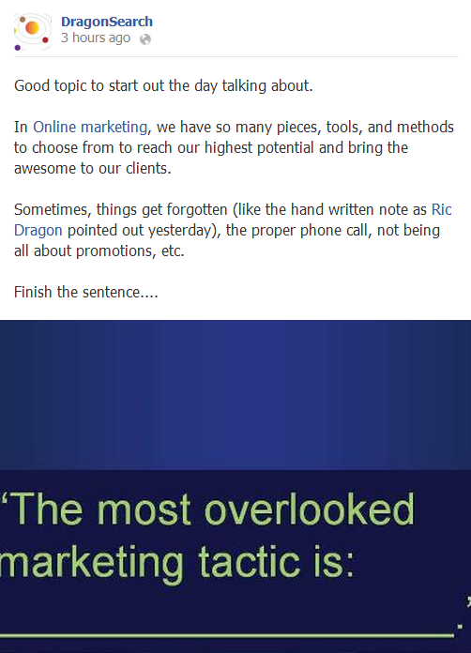  Excellent, because this invites reponses. The image also breaks up the monotonous flow of the wall… | 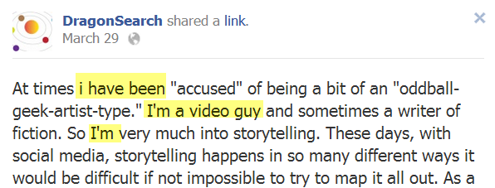  [in posting as DragonSearch, avoid “I” and “me”.]
 | - avoid contentious subjects outside of our field